**OOP ASSIGNMENT**

**Submitted by: Kyrshanlang R. Dkhar**

**Class: MCA 2nd Semester**

**Roll No: 1**

**Contents**

1. **Program to print Diamond.**
2. **Calendar App in CPP.**
3. 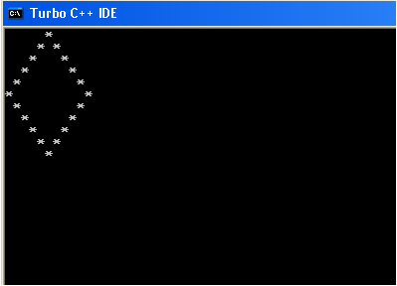**Program to Print Diamond. OUTPUT**

#include<iostream.h>

#include<conio.h>

void main(){

clrscr();

int z=1, i,j,k;

for(i=0;i<=5;i++){

for(j=5;j>i;j--)

cout<<" ";

cout<<"*";

if(i>0){

for(k=1;k<=z;k++)

cout<<" ";

z+=2;

cout<<"*";

}

cout<<endl;

}

z-=4;

for(i=0;i<=4;i++){

for(j=0;j<=i;j++)

cout<<" ";

cout<<"*";

for(k=1;k<=z;k++)

cout<<" ";

z-=2;

if(i!=4)

cout<<"*";

cout<<endl;

}

getch();

}

1. **Calendar Program**

//CALENDAR PROGRAM

#include<iostream.h>

#include<conio.h>

#include<stdio.h>

class Date{

int date,month;

public:

Date();

void setDate(int);

void setMonth(int);

int getDate();

int getMonth();

};

class Calendar : public Date{

public:

Calendar();

Calendar(int,int);

void displayDay();

void displayMonth();

int num_days_month();

};

void main()

{

int ch=0;

Calendar c, c1(2,2);

while(ch!=3){

clrscr();

cout<<"\n\t 2016 CALENDAR PROGRAM";

cout<<"\n\n\t MENU\n";

cout<<"1. Display Month.";

cout<<"\n2. Display Day.";

cout<<"\n3. Exit.";

cout<<"\n Enter Your Choice: ";

cin>>ch;

switch(ch){

case 1:

c.displayMonth();

break;

case 2:

c.displayDay();

//c1.displayDay();

break;

case 3:

cout<<"Exiting Program... Press any key";

break;

default:

cout<<"You Entered and invalid Input\n";

getch();

}

}

getch();

}

Date::Date(){

date=month=1;

}

Calendar::Calendar(){

setDate(1);

setMonth(1);

}

Calendar::Calendar(int d,int m){

if((d>0 && d<31) && (m>0 && m<12)){

setMonth(m);

setDate(d);

}

else{

setMonth(1);

setDate(1);

}

}

void Date::setDate(int day){

if(month==2){

if(day<30 && day>0)

date=day;

else{

date=1;

cout<<"Date is : "<<date<<"/"<<month<<"/2016\n";

}

}

else if(month==1 || month==3 || month==5 || month==7 || month==8 || month==10 || month==12){

if(day<32)

date=day;

else{

date=1;

cout<<"Date is : "<<date<<"/"<<month<<"/2016\n";

}

}

else{

if(day<31)

date=day;

else{

date=1;

cout<<"Date is : "<<date<<"/"<<month<<"/2016\n";

}

}

}

void Date::setMonth(int mon){

if(mon>=1 && mon<=12)

month=mon;

else{

month=1;

cout<<"Invalid month. Month set to Jan\n";

}

}

int Date::getMonth(){

return month;

}

int Date::getDate(){

return date;

}

void Calendar::displayDay(){

int d,m,day,i,num_days=0;

char ch;

cout<<"\nDisplaying the day.\n";

cout<<"Do You Want to Set the Date: Y/N \n";

cin>>ch;

if(ch=='Y' || ch=='y'){

cout<<"Enter Day";

cin>>d;

cout<<"Enter Month: ";

cin>>m;

setMonth(m); setDate(d); //set Month then the date

}

for(i=1;i<getMonth();i++){

if(i==2) num_days+=29;

else if(i==1 || i==3 || i==5 || i==7 || i==8 || i==10 || i==12)

num_days+=31;

else num_days+=30;

}

num_days=num_days+(getDate()-1);

cout<<endl<<getDate()<<"/"<<getMonth()<<"/2016 is a ";

day=num_days%7;

if(day==0)

cout<<"FRIDAY";

else if(day==1)

cout<<"SATURDAY";

else if(day==2)

cout<<"SUNDAY";

else if(day==3)

cout<<"MONDAY";

else if(day==4)

cout<<"TUESDAY";

else if(day==5)

cout<<"WEDNESDAY";

else if(day==6)

cout<<"THURSDAY";

getch();

}

int Calendar::num_days_month(){

int month=getMonth();

if(month==2)

return 29;

else if(month==1 || month==3 || month==5 || month==7 || month==8 || month==10 || month==12){

return 31;

}

else

return 30;

}

void Calendar::displayMonth(){

int m,d=1,firstday,max_days,i,num_days=0;

cout<<"Enter Month: ";

cin>>m;

setMonth(m);

setDate(d);

max_days=num_days_month();

//Know Which day is Firstday

for(i=1;i<getMonth();i++){

if(i==2)

num_days+=29;

else if(i==1 || i==3 || i==5 || i==7 || i==8 || i==10 || i==12)

num_days+=31;

else

num_days+=30;

}

num_days=num_days+(getDate()-1);

firstday=num_days%7;

switch(getMonth()){

case 1:

cout<<"\n\t JANUARY \n"; break;

case 2:

cout<<"\n \t FEBRUARY\n"; break;

case 3:

cout<<"\n\tMARCH\n"; break;

case 4:

cout<<"\n\tAPRIL\n"; break;

case 5:

cout<<"\n\t MAY \n"; break;

case 6:

cout<<"\n \t JUNE\n"; break;

case 7:

cout<<"\n\tJULY\n"; break;

case 8:

cout<<"\n\tAUGUST\n"; break;

case 9:

cout<<"\n\t SEPTEMBER \n"; break;

case 10:

cout<<"\n \t OCTOBER\n"; break;

case 11:

cout<<"\n\t NOVEMBER\n"; break;

case 12:

cout<<"\n\t DECEMBER\n"; break;

}

cout<<"\tSUN \t MON \t TUE \t WED \t THU \t FRI\t SAT \n";

switch(firstday){

case 0: //Friday

cout<<"\t \t \t \t \t \t "<<d; break;

case 1: //Saturday

cout<<"\t \t \t \t \t \t \t "<<d; break;

case 2: // Sunday

cout<<"\t "<<d; break;

case 3: //Monday

cout<<"\t \t "<<d; break;

case 4: //TUesday

cout<<"\t \t \t "<<d; break;

case 5: //Wed

cout<<"\t \t \t \t "<<d; break;

case 6: //Thurs

cout<<"\t \t \t \t \t "<<d; break;

}

d++;

if(firstday!=1)

for(;d<=max_days;d++){

cout<<"\t "<<d;

firstday++;

if(firstday==1)

cout<<endl;

else if(firstday==7)

firstday=firstday%7;

}

else

for(;d<=max_days;d++){

if(firstday==1)

cout<<endl;

else if(firstday==7)

firstday=firstday%7;

cout<<"\t "<<d;

firstday++;

}

getch();

}

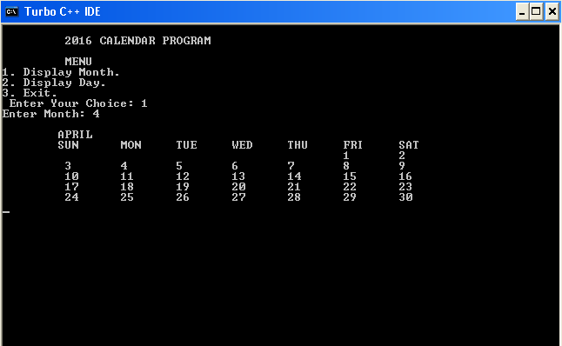**OUTPUTS**

